**Sub-recipient Name:** Bridge Intelligence LLC

**Subaward No:** 00000286

**Principal Investigator:** Hooman Parvardeh

**LTBP TSSC**

**Federal Contract # DTFH61-17-D00001**

PROGRESS REPORT NO. 19

For the Period from 4/1/2019 through 5/31/2019

# Accomplishments/Work Performed

The following is a complete account of all accomplishments and work performed on each task during this reporting period.

# Task 1: (Coordination and Meetings between the Rutgers and FHWA LTBP Team)

During this period, Mr. Parvardeh had a few correspondences with the FHWA team over the email.

Number of hours during this period: 1.5 hours

# Task 2: (Data Gap Analysis)

During this period, Mr. Parvardeh converted the XML maintenance data from state 2 to a tabular format which is appropriate for analysis. Afterwards, Mr. Parvardeh worked on cleaning the data to make it ready for analysis. Then, Mr. Parvardeh completely developed similar query and visualization tool which allows the user to query the data and see different charts to be able to freely answer different questions. Screenshots from this tool is shown below.

To access the dashboards, you can use the following links.

State1: <https://app.powerbi.com/view?r=eyJrIjoiN2RkZjE3MTUtNDIwOC00ZjJkLTk5ZTItNWFiNzU3ODJlNjk5IiwidCI6IjIzZjI0MDk2LTdiMjktNDQ1NC1iOWVlLTM1MDQyMjI4M2FiMiIsImMiOjJ9>

State2: <https://app.powerbi.com/view?r=eyJrIjoiYmYyOGJhYTItYmNhYy00MTNlLWE0NTctZThjNDJhNGU0YzlmIiwidCI6IjIzZjI0MDk2LTdiMjktNDQ1NC1iOWVlLTM1MDQyMjI4M2FiMiIsImMiOjJ9>

Below you can see screenshots of dashboards from both states:

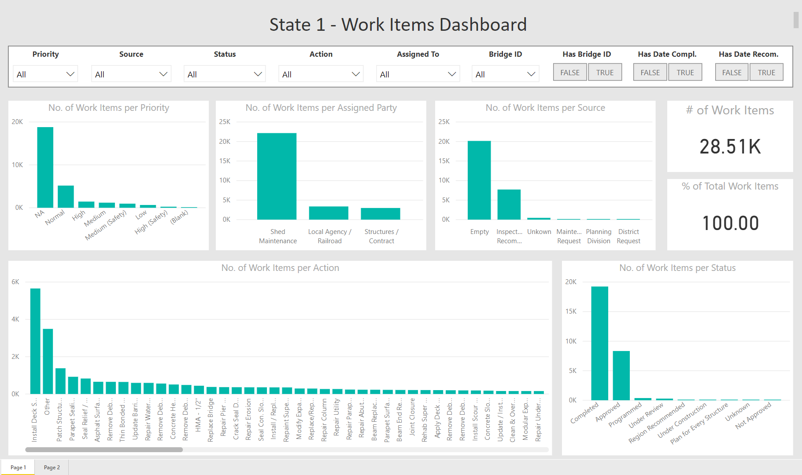

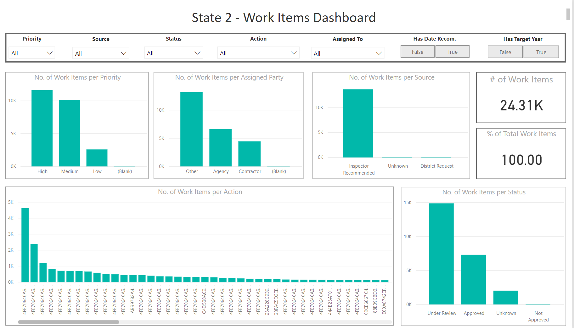

Lastly, Mr. Parvardeh developed a draft report and submitted it to Rutgers for final review and modifications.

Number of hours during this period: 48.7 hours

# Task 3: (Communication)

During this period, Mr. Parvardeh performed the following tasks:

* Prepared and submitted monthly progress report to FHWA
* Updated the MS project file and submitted it to FHWA

Number of hours during this period: 18 hours

# Work Anticipated During the Next Period

None.

# Changes /Problems

None.

# Participants & charged Level of Efforts

|  |  |  |  |
| --- | --- | --- | --- |
| **Personnel Name** | **Role/Contribution** | **Total Hours** | **Billed Cost** |
| Hooman Parvardeh | Principal | 68.2 | $ 9,138.80 |

Below is a breakdown of level of effort per task:

|  |  |  |
| --- | --- | --- |
| Task 1 | Task 2 | Task 3 |
| 1 hr | 48.7 hrs | 18 hrs |

# Travel

None.